NCC – DEV STACK Architecture

PREPARED BY:
“ Nexus Fortified Structures, LLC”

5 12.217. 0 654
paul@nfsgrp.com

 | Central Texas |  | General Contractor
 | 301 Main Plaza Suite 191 New Braunfels TX 78133 |  | FL / NC / SC / NM / AK / TX / GA / NC / MS / AL
 | Central Florida
 | 460 N SR 434 Altamonte Springs FL 32714

Document TOC (Table Of Contents):

Document TOC (Table Of Contents): 2
Executive Summary of the Stack Architecture 3
Current Stack Graphic 3
Why We Chose This Path 4
Steps for Full Evaluation of the Nexus App 4
Technology Roadmap/Path 5
Phase 1: Stabilization and Evaluation (1-2 Months) 5
Phase 2: Enhancement and Integration (2-3 Months) 5
Phase 3: Scaling and Production Readiness (3-4 Months) 6
Phase 4: Expansion and Maintenance (Ongoing) 6
Dev Environment: Data Handling and Migration to GCP for Production 7
Current Dev Environment Setup 7
Data Flow and Migration to GCP Production 7

Executive Summary of the Stack Architecture
The Nexus Connect App (NCC) employs a modern, scalable full-stack architecture centered on TypeScript and Fastify for the backend, Prisma as the ORM for type-safe database interactions, PostgreSQL as the relational database (currently v16/v17, fully compatible with v18), and Redis for caching and real-time features.
This stack supports the app's core requirements for user authentication, role-based access control, project management, daily logs, tagging system, workflow engine, reports & export, and invoice preparation, as outlined in the MVP feature set and milestone breakdowns.
Fastify serves as the high-performance backend framework, leveraging its extremely fast routing, low overhead, schema-based validation (via fastify/ajv), and plugin ecosystem to efficiently handle API requests. Its lightweight and flexible nature makes it particularly well-suited for a construction project management application that requires high throughput for concurrent user sessions (daily logs, project updates, workflow notifications) while keeping operational costs and response times low.
PostgreSQL delivers robust data integrity, advanced querying capabilities, and strong support for structured data such as projects, logs, tags, and user roles. Prisma simplifies database migrations, schema management, and type-safe queries with auto-generated clients, significantly reducing boilerplate and potential errors. Redis enhances performance by caching frequently accessed data (e.g., user sessions, project statuses) and enabling pub/sub patterns for real-time notifications and workflow triggers.
The frontend integrates seamlessly via React Native for the mobile app and Next.js for both the web application and admin panel, all connecting to the centralized Fastify REST API secured with JWT.
This unified JavaScript/TypeScript stack prioritizes performance, developer control, and flexibility while offering cost-effective, open-source components with strong community support and smooth integration paths for external services such as Google APIs, Google Sheets, Twilio, SendGrid, and future additions like Stripe.

Why We Chose Fastify + Prisma + PostgreSQL + Redis
We deliberately selected Fastify as our backend framework for the following key reasons:
- Exceptional performance — one of the fastest Node.js web frameworks available, critical for handling high-frequency updates (daily logs, real-time workflow notifications) in a multi-user construction environment
- Lightweight & flexible — full developer control without imposed structure, allowing us to shape the architecture exactly to our needs
- Strong plugin ecosystem — excellent support for authentication, rate limiting, schema validation, logging, and Redis integration
- Schema-first validation — built-in JSON Schema support via fastify/ajv provides fast, secure input validation for all API endpoints
- Modern TypeScript support — excellent type inference and developer experience when combined with Prisma and modern tooling
Criterion | NestJS | Fastify (Chosen Path) | Winner for NCC
Performance | Very good | Exceptional (among the fastest in Node.js) | Fastify
Structure & Maintainability | Built-in modules, DI, decorators | Developer-defined structure — full control | Fastify (our preference)
Flexibility | Opinionated structure | Highly flexible & lightweight | Fastify
Learning curve / onboarding | Moderate (Angular-like concepts) | Lower — closer to Express but faster & modern | Fastify
Validation | Class-validator / pipes | Native JSON Schema (very fast) | Fastify
Future complexity handling | Scales well with built-in patterns | Scales well with good discipline & plugins | Tie (depends on team)

Key Decision Rationale:
Fastify was chosen because we prioritize raw performance, minimal overhead, and maximum control over the API layer while still benefiting from Prisma's type safety and Redis for real-time features. This combination gives us the speed needed for frequent log submissions and notifications without the additional abstraction layers that come with more opinionated frameworks.

Current Stack Graphic
Below is a visual representation of the current stack architecture, adapted from the provided diagram but updated to reflect the Node.js-PostgreSQL-Prisma-Redis setup (replacing Laravel/MySQL). I've used Mermaid syntax for clarity, showing key components, data flows, and integrations.
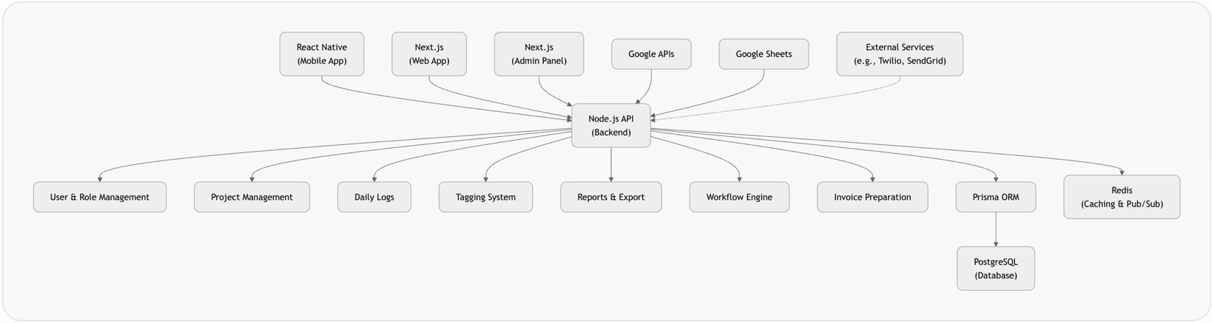

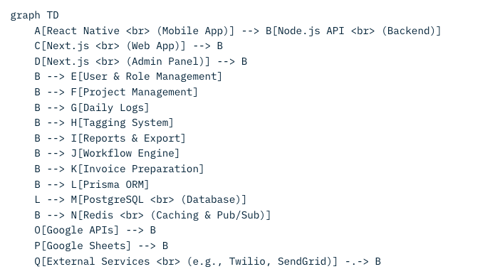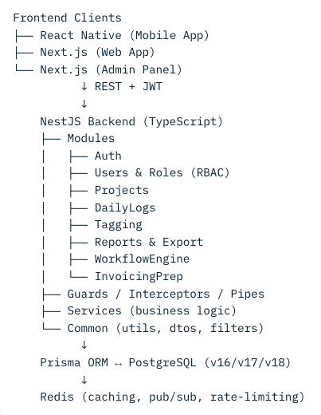
Dev Environment & Production Path (GCP)
Development Environment:
- Local: Docker Compose or direct installs (Fastify server, PostgreSQL, Prisma, Redis)
- Dev data: Generated locally via Prisma seed scripts (fake/test data only)
Migration to Production (GCP):
- Export schema/data via pg_dump + Prisma migrations
- Import to Cloud SQL (PostgreSQL)
- Redis: Export RDB → import to Memorystore
- Deploy Fastify: Docker image → Cloud Run or App Engine
- Secrets: GCP Secret Manager
- CI/CD: GitHub Actions / Cloud Build
- Monitoring: Cloud Logging + Prometheus
This ensures clean separation of dev/staging/prod environments and safe, scalable promotion to production.

This diagram illustrates the centralized Node.js API as the core hub, with Prisma mediating database interactions and Redis handling performance-critical elements. Arrows indicate primary data flows; dotted lines show optional integrations.

Why We Chose This Path
The selection of Node.js, PostgreSQL, Prisma, and Redis for the Nexus Connect App was driven by several strategic considerations:
- Developer Efficiency and Ecosystem Unity: Node.js allows for a full JavaScript/TypeScript stack across frontend (Next.js/React Native) and backend, enabling code reuse, faster onboarding, and reduced context-switching for developers. This is particularly beneficial for a small team iterating on MVP features like daily logs and project management.
- Performance and Scalability: Node.js's asynchronous nature excels in I/O-heavy apps like NCC, where users submit logs, update projects, or trigger workflows concurrently. Redis complements this by providing sub-millisecond caching for session management and real-time notifications (e.g., workflow triggers), preventing database bottlenecks. PostgreSQL was chosen over MySQL (as in the initial diagram) for its superior support for complex queries, JSON data types (useful for tags and logs), and ACID compliance, ensuring data reliability in multi-user scenarios.
- Modern Tooling and Maintainability: Prisma offers type-safe queries, automatic schema migrations, and GraphQL/REST API generation, which streamlines development for features like RBAC and tagging. It reduces SQL injection risks and boilerplate code compared to raw queries or other ORMs. This choice supports rapid prototyping in Phase 1 while facilitating future milestones like invoicing integration.
- Cost and Community Support: All components are open-source with strong communities, minimizing licensing costs. PostgreSQL and Redis have excellent free tiers on cloud providers like GCP, and Node.js deploys easily to serverless environments. This path avoids vendor lock-in from frameworks like Laravel, allowing flexibility for integrations (e.g., Google Sheets for invoicing prep).
- Alignment with App Requirements: Based on the milestone breakdown, this stack handles real-time elements (e.g., notifications via Redis pub/sub), structured data (PostgreSQL for projects/logs), and API-centric design for mobile/web clients. It positions NCC for growth, such as adding payments (Stripe) or real-time comms (Pusher) without major rewrites.
This path was likely influenced by the need to pivot from the diagram's Laravel/MySQL setup for better JavaScript alignment and performance in a construction app with frequent updates.

Steps for Full Evaluation of the Nexus App
To conduct a comprehensive evaluation of the Nexus Connect App, we need a structured process that assesses functionality, performance, security, usability, and alignment with the MVP feature set and milestones. Here's a step-by-step plan:
- Gather Documentation and Assets: Review all existing docs (e.g., the provided MVP Feature Set and Milestone Breakdown), code repositories, API specs, and the architecture diagram. Identify gaps between planned features (e.g., tagging system, workflow engine) and implemented ones.
- Technical Audit:
  - Code Review: Use tools like SonarQube or manual peer reviews to check code quality, adherence to best practices (e.g., Prisma schema consistency), and test coverage.
  - Dependency Analysis: Scan for outdated libraries (e.g., Node.js version, Prisma updates) using npm audit or Snyk.
  - Performance Testing: Run load tests with tools like Artillery or JMeter to simulate user traffic on daily logs and project dashboards. Measure API response times, database query efficiency, and Redis hit rates.
  - Security Scan: Perform vulnerability assessments with OWASP ZAP or Trivy, focusing on authentication (e.g., JWT in Node.js), RBAC enforcement, and data encryption.
- Functional Testing:
  - Map features to milestones: Test user auth, project creation, daily logs, tagging, exports, workflows, and invoicing prep against the docs.
  - Use automated tests (e.g., Jest for Node.js) and manual QA for edge cases like role-based access or file uploads.
  - User Feedback Loop: Conduct usability sessions with stakeholders (e.g., project managers) to evaluate intuitiveness.
- Infrastructure Review:
  - Assess current dev/staging/prod environments (detailed below).
  - Evaluate scalability: How does the stack handle 100+ concurrent users? Test Redis for caching workflows.
- Data and Compliance Check: Ensure data models (via Prisma) align with requirements (e.g., tags on logs). Verify GDPR/HIPAA compliance if handling personal data.
- Gap Analysis and Reporting: Document findings in a report, highlighting strengths (e.g., scalable API) and issues (e.g., missing integrations). Prioritize fixes based on milestones.
This evaluation should take 2-4 weeks, involving devs, QA, and stakeholders.

Technology Roadmap/Path
The technology roadmap outlines a phased path to mature the Nexus app from MVP to full production, focusing on stability, scalability, and feature expansion. It builds on the current stack while addressing dev-to-prod transitions and integrations from the milestone docs.

Phase 1: Stabilization and Evaluation (1-2 Months)
- Complete the full evaluation as outlined above.
- Implement quick wins: Add unit/integration tests for core features (auth, projects, logs).
- Integrate basic monitoring (e.g., Prometheus for Node.js metrics, Redis insights).
- Milestone Alignment: Ensure Milestones 1-3 (User/Role Mgmt, Project Mgmt, Daily Logs) are fully functional.

Phase 2: Enhancement and Integration (2-3 Months)
- Add tagging, reports, and workflows (Milestones 4-6): Leverage Prisma for schema updates and Redis for workflow notifications.
- Integrate external services: Google Sheets/API for invoicing prep, Twilio/SendGrid for comms.
- Optimize performance: Implement advanced caching in Redis for frequent queries (e.g., project lists).
- Security Upgrades: Add OAuth for Google integrations, rate limiting in Node.js.

Phase 3: Scaling and Production Readiness (3-4 Months)
- Migrate to GCP (details below): Deploy Node.js to App Engine or Cloud Run, PostgreSQL to Cloud SQL, Redis to Memorystore.
- Add advanced features: Invoicing module (Milestones 7-8), real-time updates (WebSockets via Node.js/Redis).
- Implement CI/CD: Use GitHub Actions or Cloud Build for automated deployments.
- Analytics: Add logging with ELK stack or GCP Logging.

Phase 4: Expansion and Maintenance (Ongoing)
- Explore ML integrations (e.g., auto-tagging logs using Torch).
- Support for payments (Stripe) and e-signatures (DocuSign).
- Regular audits: Quarterly security/performance reviews.
- Future-Proofing: Monitor for stack upgrades (e.g., Node.js LTS versions).
This roadmap ensures incremental progress, with milestones tied to business value (e.g., invoicing for revenue).

Dev Environment: Data Handling and Migration to GCP for Production

Current Dev Environment Setup
- Local Development: Developers run the stack locally using Docker Compose or direct installs. Node.js server on localhost:3000 (or similar), PostgreSQL via a local instance or container (e.g., port 5432), Prisma for migrations/schema sync, and Redis for caching (port 6379). Dev data (e.g., test users, projects) is stored in the local PostgreSQL database, seeded via Prisma scripts or manual inserts. This isolates dev work without affecting production.
- Staging Environment: A cloud-based mirror (e.g., on Heroku or a dev GCP project) for testing. Data here is a sanitized copy from dev or prod, using environment variables to toggle features.

Data Flow and Migration to GCP Production
- Initial Dev Data Creation: Generate sample data locally via Prisma seed scripts (e.g., prisma db seed) with fake users, projects, and logs. Avoid real data in dev to prevent leaks.
- Migration Process:
  - Database Dump/Export: Use pg_dump for PostgreSQL to export dev schema and data as SQL files. For Prisma, run prisma migrate deploy to apply schemas.
  - Upload to GCP: Create a Cloud SQL instance (PostgreSQL-compatible) in GCP. Import the dump via gcloud sql import sql or the GCP console.
  - Data Sanitization: Before migrating to prod, anonymize sensitive data (e.g., emails) using scripts.
  - Redis Data: Export via redis-dump or RDB snapshots, then import to GCP Memorystore using gcloud redis instances import.
  - Node.js Deployment: Package the app as a Docker image, deploy to GCP App Engine or Cloud Run. Use GCP Secret Manager for env vars (e.g., DB credentials).
  - Prisma Integration: Update Prisma config to point to GCP Cloud SQL endpoint; run migrations.
- Best Practices:
  - Use version control for schemas (Prisma migrations in Git).
  - Automate with CI/CD: On push to main, trigger builds and deployments.
  - Backup: Enable GCP automated backups for Cloud SQL/ Memorystore.
  - Testing: Validate migration with a dry-run in staging first.
This ensures smooth transition from dev (local/isolated data) to prod (scalable GCP), minimizing downtime. If needed, use tools like Flyway for more complex migrations.

Current Backend Stack Confirmation (as of Dec 30, 2025)
- Language: TypeScript
- Framework: NestJS (chosen for strong structure, dependency injection, modular architecture, decorators, and the “enterprisey” feel that suits a multi-tenant construction project management app with RBAC, workflows, tagging, and future invoicing)
- ORM/Database Access: Prisma (with PostgreSQL 16/17/18 – most likely running on v16 or v17 in production as of late 2025, but fully compatible with PostgreSQL 18)
- Caching & Real-time: Redis (for sessions, pub/sub for notifications, workflow triggers, etc.)
We explicitly moved away from the lighter Express/Fastify + custom structure path because:
- The app has grown in complexity (User/Role Mgmt → Project Mgmt → Daily Logs → Tagging → Workflow Engine → Invoice Preparation + integrations with Google APIs/Sheets, potential Twilio/SendGrid, etc.)
- We needed strong typing, built-in DI, clear module boundaries, guards/interceptors/pipes for auth & validation, and easy testing/mocking
- NestJS gives us a very natural structure for the milestones, especially when implementing things like:
  - Workflow engine (services, commands, events)
  - Tagging system (custom decorators, interceptors)
  - RBAC (guards + metadata)
  - Invoice preparation logic (heavily service-based)

Decision Summary – Why NestJS over Express/Fastify
Criterion | Express/Fastify + custom | NestJS (what we chose) | Winner for NCC
Structure & Maintainability | Manual / developer-dependent | Built-in modules, DI, decorators | NestJS
Team scaling & onboarding | Slower, more conventions needed | Very fast – Angular-like structure | NestJS
Enterprise features out-of-box | Almost none | Guards, Interceptors, Pipes, CQRS… | NestJS
Testing | Manual setup | Excellent DI + Jest support | NestJS
Speed of development (MVP) | Potentially faster initially | Slightly slower start, much faster later | NestJS (long-term)
Future complexity handling | Can become messy | Scales very well with complexity | NestJS

